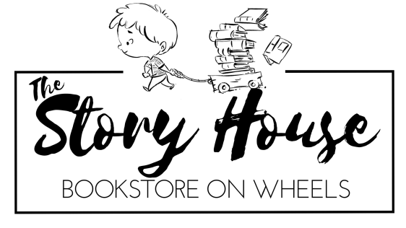
Book Fair Request Form
Name of School/Organization: Click here to enter text.
Address: Click here to enter text. Phone Number:Click here to enter text.
Main Contact Person: Click here to enter text. Phone Number: Click here to enter text.
Email Address: Click here to enter text. Alt. Phone Number: Click here to enter text.

Date(s) Requested:
First Choice or Confirmed Date(s): Click here to enter text.
Second Choice: Click here to enter text.
Third Choice: Click here to enter text.

Timing for Fair (i.e. school day, evening, morning): Click here to enter text.

Type for the Fair (see descriptions on the next page):
- Trolley Book Fair: ☐
- In-school Book Fair with Trolley Visit: ☐
- Single Event: ☐ Type of Event: Click here to enter text.
- Online Book Fair:☐ Trolley Visit Requested During Online Fair: ☐
- Other, please describe: Click here to enter text.

Are you interested in setting up an author visit in conjunction with the fair? Subject to availability and additional fee applies. Yes☐ No☐ Maybe☐

Please estimate the total number of people who will visit the fair: Click here to enter text.

For schools, please share the total number of students or classes by grade. An estimate is fine.
Grade | Number | Grade | Number
Pre-school | Click here to enter text. | Sixth | Click here to enter text.
Kindergarten | Click here to enter text. | Seventh | Click here to enter text.
First | Click here to enter text. | Eighth | Click here to enter text.
Second | Click here to enter text. | Ninth | Click here to enter text.
Third | Click here to enter text. | Tenth | Click here to enter text.
Fourth | Click here to enter text. | Eleventh | Click here to enter text.
Fifth | Click here to enter text. | Twelfth | Click here to enter text.

Please tell us a little about your school or organization and your vision for the fair/event: Click here to enter text.
Types of Fairs
Trolley Book Fair: The Story House will arrive with the trolley filled with books especially selected for your school or organization. Classes will visit the trolley and students will choose the book or books that they want to purchase. Since the fair is multi-day, the trolley will be restocked at night and filled with books appropriate for the grades visiting the next day. At least one family night will be scheduled. Schools will earn 15% in cash or 25% in book credit on the first $5000 raised and 20% in cash or 35% in book credit on all funds raised over $5000. This fair requires parent volunteers, but fewer than an in-school fair.
In-School Book Fair with a Trolley Visit: The best of both worlds. The trolley will visit, filled with 2000 individual titles. In addition, multiple copies of featured books will be set up inside the school. This multi-day model allows for a larger selection of books and more space for multiple classes to visit at once, but requires additional parent volunteers. At least one family night will be scheduled. Schools will earn 15% in cash or 25% in book credit on the first $5000 raised and 20% in cash or 25% in book credit on all funds raised over $5000. This fair format requires additional parent volunteers to set-up and man the in-school portion.
Single event Book Fair: The Story House trolley will visit a school or another organization for a special event and fill a portion of bookmobile with related titles. For example, at a school science fair, STEM titles would be available whereas on multicultural night, there would be books reflecting diversity. This format also works for non-profit organizations and faith groups. For example, an arts center might invite the Story House to sell art books on the night of a show or a pre-school might have the Story House visit on truck day, with a bookcase devoted to books on transportation. Schools will earn 12.5% cash or 25% in book credit.
Online Book Fair: The Story House will set up a section on its website especially for the school or organization, with recommended titles and teacher book reviews. During the Book Fair, families can order the suggested books or any other title available through Ingram wholesale, including books for adults. A trolley visit can be scheduled during the fair. When the books arrive, they will be sorted and distributed by volunteers. Schools will earn 20% cash or 35% in book credit for online book fairs.
The Story House – Main Responsibilities
- Provide the tools needed to plan a successful fair, including publicity materials and a planning guide.
- Collaborate on choosing a book list for the fair.
- Stock high quality, new copies of books for the fair. Books, sold at a discount, are remainders and overrun copies.
- Help set up an author visit, if requested. Separate fee applies.
- Have a staff person on site when the Story House trolley is being used.
- Set-up an easy to use point of sale cash register system.
- Collect all moneys and provide an accurate accounting of the sale.
- Pay the school/organization commission, as described above, in a timely fashion.
School/Organizations – Main Responsibilities
- Publicize the fair to your school or organization. Sample ads, promo texts and flyers will be provided.
- Assign one person to be the main contact for the fair.
- Collaborate on choosing a book list for the fair.
- Provide a secure, safe, flat spot for the Story House trolley to park with safe access for fair-goers.
- If the fair includes an in-school portion, provide a secure, appropriate location.
- Stolen or harmed merchandise is the school’s responsibility.
- Recruit volunteers to help with set-up, sales, inventory and pack-up.
Cancellations, Weather Emergencies, Mechanical Issues
- School and organizations may cancel their book fair or event up to 6 weeks before the date without penalty. After that, the school or organization is responsible for the cost of return shipping for all books ordered for the fair.
- In cases of inclement weather causing school and activity closings, every attempt will be made to reschedule the fair or event to a mutually agreeable time.
- The Story House Trolley is in good mechanical condition. In the rare instance of mechanical breakdown, the Story House will give the school or organization the following choices: reschedule the fair or move the fair to an indoor location and find a separate time for the trolley to visit the school.

